

**Tensile Testing**

**All activities**

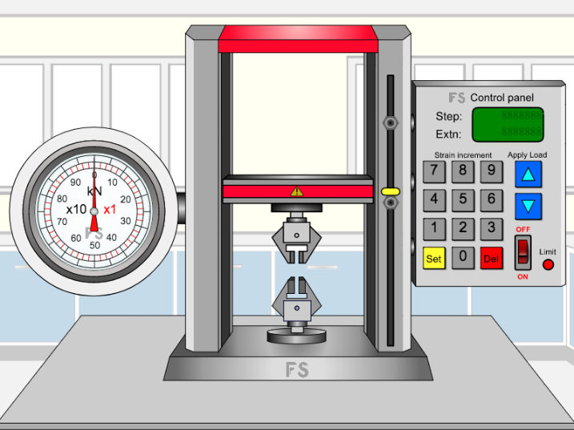



[www.flashyscience.com](http://www.flashyscience.com)

**FlashyScience** **Tensile Testing Activities**

**Quick activities:**

|  |  |
| --- | --- |
| 1. | Choose any of the materials and use small strain increments to determine its Young’s modulus. |
| 2. | Which material has *(a)* the highest and *(b)* the lowest Young’s modulus from your measurements in the experiment above? |
| 3. | Which of the five materials can stretch elastically the most? |
| 4. | 1. Choose one of the metal samples (1 – 3) and use small strain increments to determine its elastic limit. 2. (Advanced question) Continue to stretch the sample with small strain increments and determine the 0.2% yield strength. |
| 5. | Determine the UTS for all five sample types. Which has the highest UTS and which has the lowest? |
| 6. | 1. Measure the full stress-strain curve for samples 1 (steel), 2 (brass) and 3 (aluminium alloy). 2. What type of behaviour is observed from these stress-strain curves? 3. Which material has the greatest UTS? 4. Which material should be chosen when high strength is required? 5. Why are the other two materials still used (hint – think about other properties not explored here)? |
| 7. | 1. Measure the full stress-strain curve for samples 4 (glass) and 5 (Kevlar). 2. What type of behaviour do these materials exhibit? 3. Why are these properties useful in applications? |
| 8. | (Advanced experiment)   * 1. For one or more materials, measure the full stress-strain curve to fracture.   2. Convert the data to true stress and true strain.   3. Estimate the work done in fracturing each sample investigated. |
| 9. | 1. Select one of the metal samples (1 – 3) and increase the strain to determine the sample’s yield strength. 2. Continue to increase the strain a little more (use your judgement but record what you do) and then reduce the applied strain in steps to relax the sample (the applied load will be at zero) 3. Record the strain (permanent deformation) at this point. 4. Increase the strain again to calculate the new yield strength of the material. 5. Repeat steps b – d to find how the yield strength changes as the sample undergoes these repeated strain cycles (work hardening). |

**ACTIVITY 1: ELASTIC DEFORMATION**

*AIM: Investigate elastic deformation*

1. Select one of the metal samples (1 – 3). Measure and record its width, and calculate its cross-sectional area. (REMEMBER – sample thickness is always exactly 5 mm here)
2. Click ‘USE’ to place the chosen sample in the tensile testing machine.
3. Investigate adding small increments of strain to increase the applied stress. Record the strain and load at each point (and calculate the applied stress). Cycle the strain up and down (at low values) to determine:
   1. Young’s modulus
   2. Elastic limit
   3. 0.2 % yield strength

HINT: Try using a ‘dummy’ sample first to work out the right order of magnitude of strain increments that you should be using.

**ACTIVITY 2: PLASTIC DEFORMATION**

*AIM: Investigate how materials can be permanently deformed*

1. Measure the width of a new sample (1 – 3) and place it in the tensile testing machine.
2. Increase the strain with a number of increments, recording all data at each step. Go beyond the onset of plastic deformation but not as far as the UTS.
3. Reduce the applied load to zero by reducing the strain (again, in steps and recording all data). Observe what has happed to the strain. What does this represent and why does it occur?
4. Calculate the engineering stress and strain (Advanced question: also calculate true stress and strain).
5. (Advanced question) Plot true stress vs true strain and estimate the work done in creating the permanent deformation.

**ACTIVITY 3: FRACTURE**

*AIM: to investigate fracture of a material*

1. Measure the width of a new sample (any sample) and place it in the tensile testing machine.
2. Increment the strain to take the sample through the UTS and onto fracture, recording all data as necessary at each step (HINT: again, perhaps use a ‘dummy’ sample of the same material first to establish the order of magnitude of the strain increments. Otherwise you may have too many or too few data points. You don’t need to use the same strain step in each region – the plastic regions usually have a lower gradient, so larger strain increments can be used without undue loss of accuracy).
3. From a plot of engineering stress vs engineering strain determine the UTS.